BARRYVOX S FRGMT EDITION: a Mammut x Fragment Design collaboration
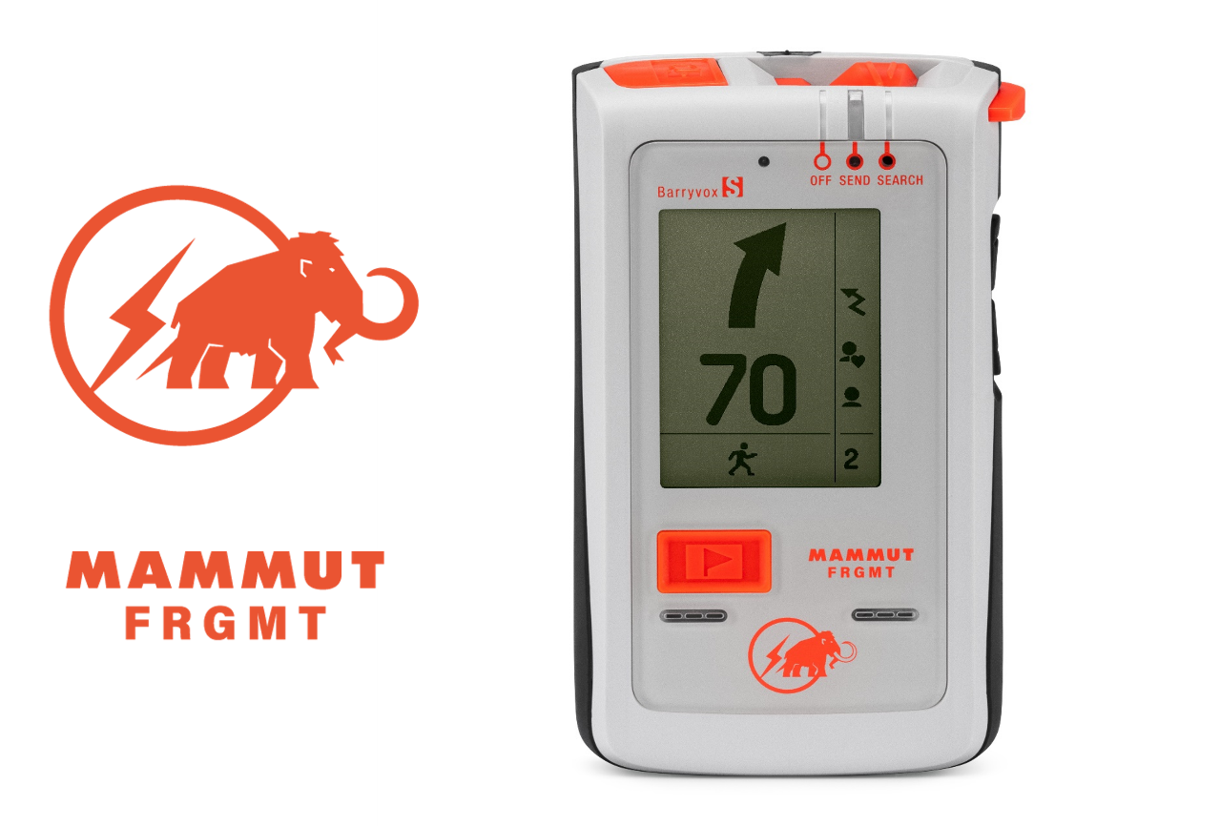
Barryvox S FRGMT Edition: A collaboration project with fragment design. (Photo: ©Mammut Sports Group AG)

Just in time for snow season, Mammut is set to launch the limited Barryvox S FRGMT Edition. This unique product is the result of a collaboration with «fragment design», a design project led by the Japanese designer Hiroshi Fujiwara. The Mammut Barryvox S is a multiple award-winning avalanche beacon and an indispensable tool for snow enthusiasts.

This collaboration introduces a specially designed Barryvox S, courtesy of fragment design. The uniqueness of this design is apparent in its distinct body color and the placement of the iconic «FRGMT x Mammut» collaboration logo on the front of the device. The «Safety Orange» color is used throughout the product, making it highly visible and easy to operate. Furthermore, the startup animation sets this model apart from the standard version. But while the collaboration model boasts these special design elements, its fundamental performance remains consistent with the conventional Barryvox S.

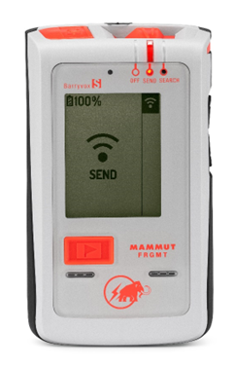 | 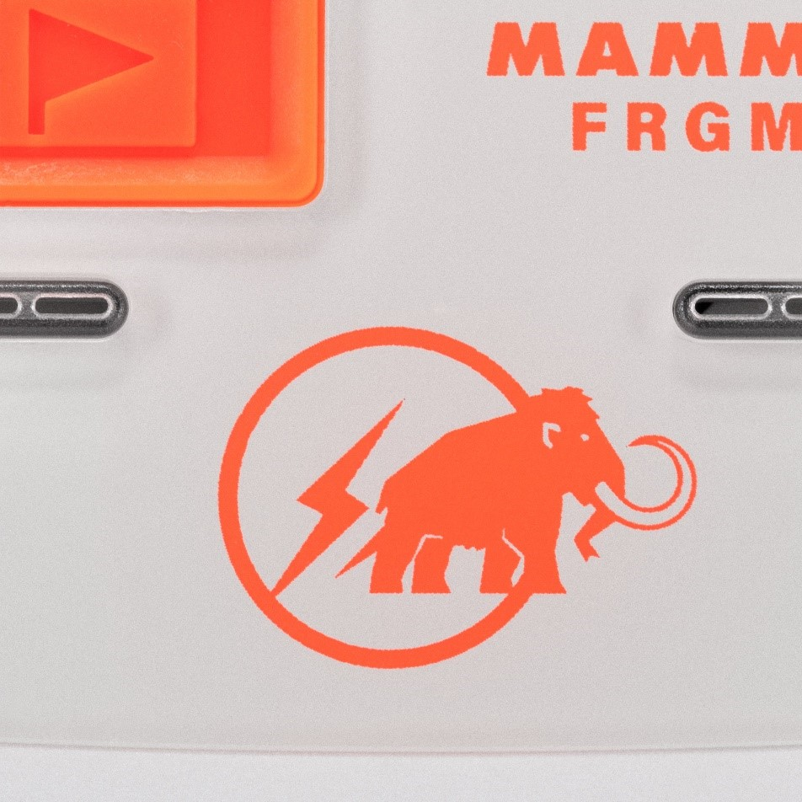  Product number: 2620-00410  Product name: Barryvox S FRGMT Edition  RRP: 450 EURO  Release date EMEA: mid-December

Special FRGMT x Mammut logo design. (Photo: ©Mammut Sports Group AG)

The best choice for the worst case
The search for buried subjects is a true emergency situation in which the searchers are under a great deal of psychological and physical stress. This makes the simple interface and intuitive operation of the digital/analog combination device with three antennas all the more important. It has a large reception range and an effective search strip width of 70 meters.

The unique Smart Search function responds to rescuers' movements during the fine search, continuously guiding them to the target and correcting the direction via interactive graphics. This breakthrough feature helps rescuers find their target faster and makes the Barryvox S one of the most intuitive avalanche transceivers on the market. To protect non-searching rescuers, the Barryvox S incorporates the Rescue SEND function. In the event of a secondary avalanche burial, the device automatically switches to SEND to locate buried rescuers.

The Barryvox S FRGMT Edition will be globally available online in a limited quantity. Furthermore, it will be on display from Nov 28th-30th at the ISPO Munich 2023 at the booth of our partners from Highsnobiety.

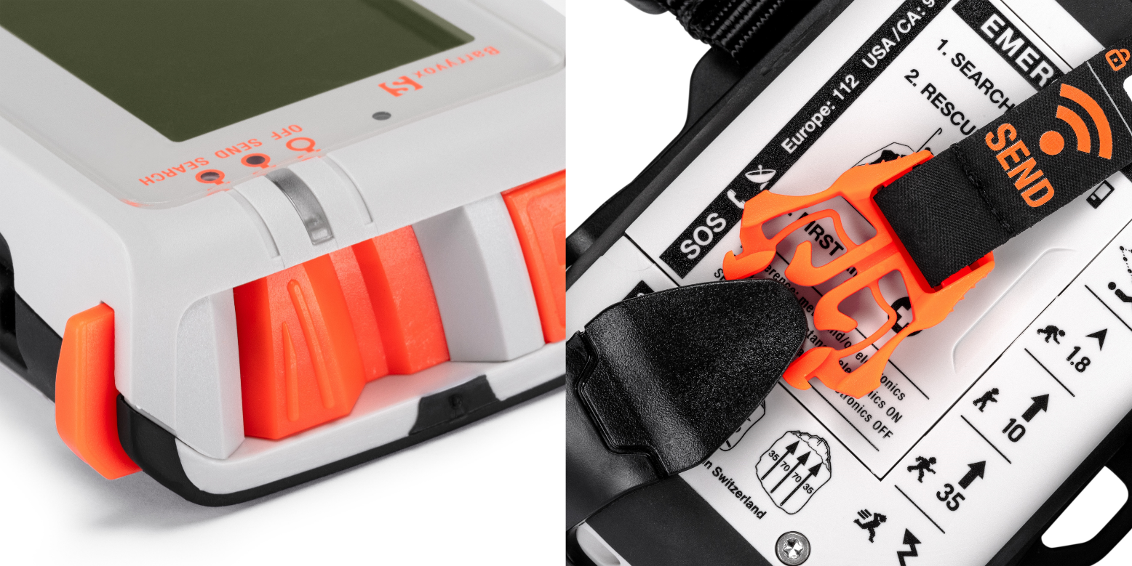
The orange color is used throughout the product, making it highly visible and easy to operate. (Photo: ©Mammut Sports Group AG)

About Mammut

Mammut is a Swiss outdoor company founded in 1862 that offers mountain sports enthusiasts worldwide high-quality products and unique brand experiences. For 160 years, the world's leading premium brand has stood for safety and pioneering innovation. Mammut products combine functionality and performance with contemporary design. With its combination of hard goods, footwear, and clothing, Mammut is one of the complete suppliers in the outdoor market. Mammut Sports Group AG is active in around 40 countries and employs approx. 800 people.

mammut.com

